Task 1:-

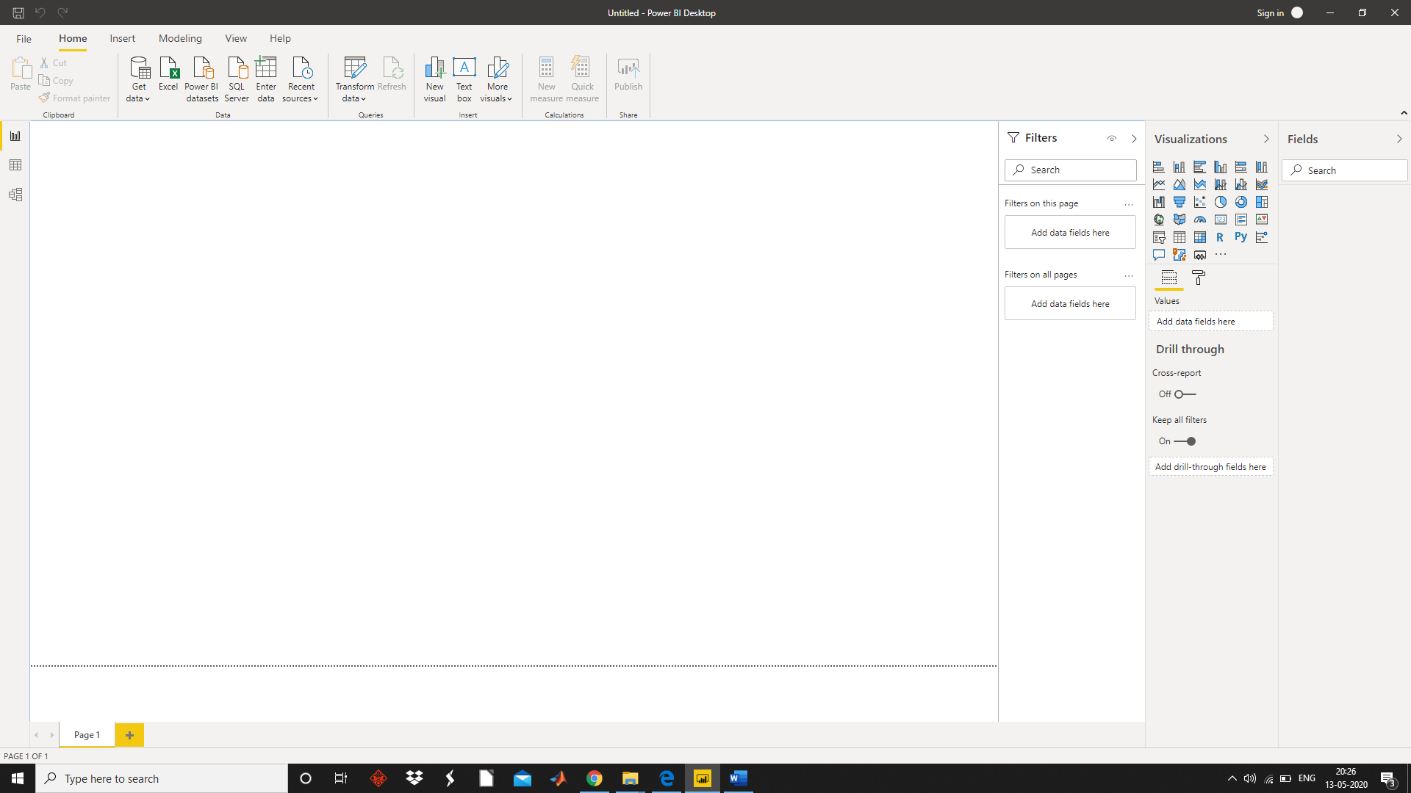

Task 2:-

Report view:-

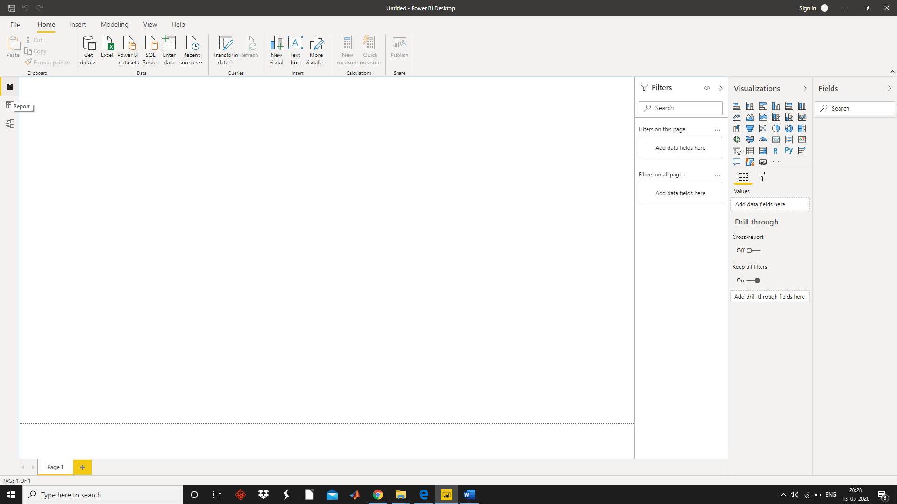

Data View:-

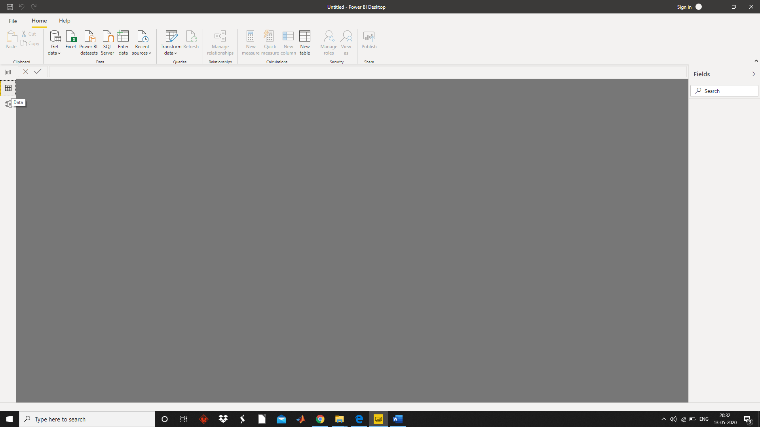

Model View:-

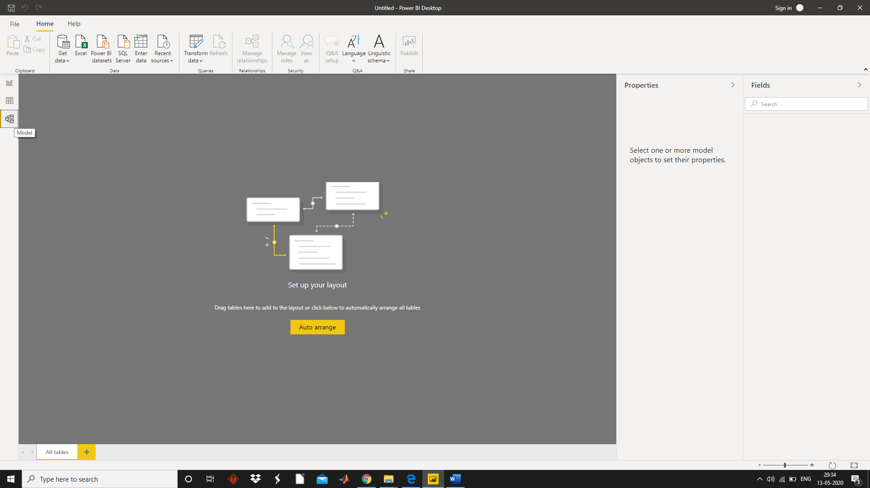

Power Query Editor:-

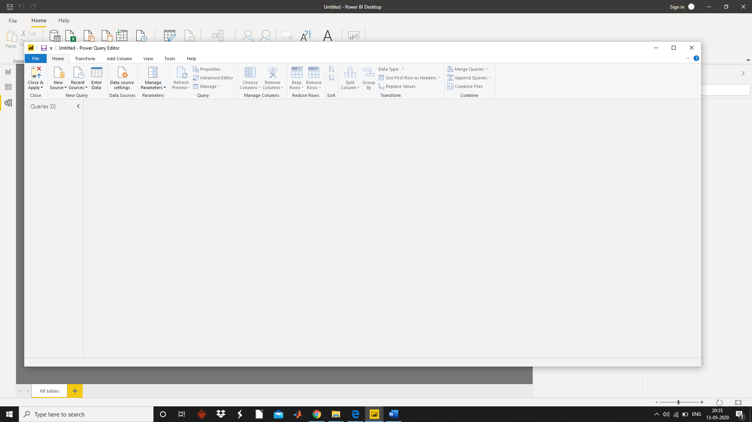

Advance Editor:-

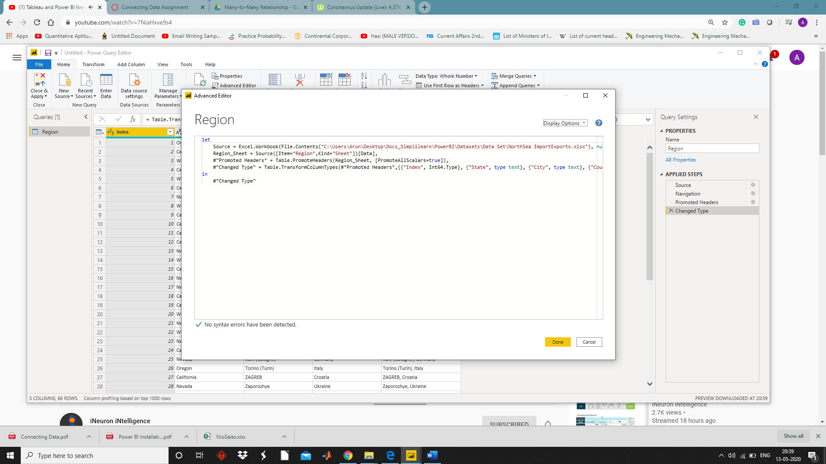

Task 3:-

|  |  |
| --- | --- |
| **Power BI Packages** | **Price** |
| Power BI Desktop | Free |
| Power BI Pro | ₹660.00 user/month |
| Power BI Premium | ₹330,190  Monthly price per dedicated cloud compute and storage resource with annual subscription |